HW4



1. Consider a dipole antenna with a/λ = 0.006 at 600 MHz.
   1. Find its resonant length and resonant resistance using the plots. Plot R and X over 470-750 MHz using Tai’s formula.

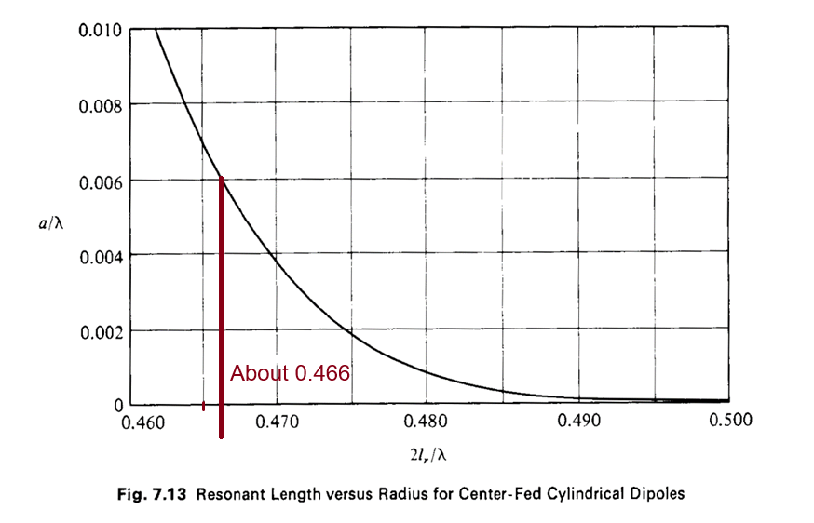

$$λ_{0}=\frac{c_{0}}{f_{0}}=\frac{299792458 m/s}{600 MHz}≈50 cm$$

$$\frac{2l_{r}}{λ}≈0.466→l_{r}≈11.64 cm$$

Dipole Length = $23.28 cm$

Figure 1 Code

syms f

lambda = 3e8/f;

length = 0.233 * 3e8/600e6;

alpha = 0.006;

k(f) = (2*pi)/lambda;

R(f) = 122.65 - 204.1*k(f)*length + 110*(k(f)*length)^2;

X(f) = -1*( 120*(log(2*length/alpha - 1) * cot(k(f)*length)) - 162.5 + 140*k(f)*length - 40*(k(f)*length)^2 );

f1 = linspace(470e6, 750e6, 20);

F = figure;

F.Position = [0,0,800,600];

centerfig(F);

yyaxis left

plot(f1./1e6, R(f1), "DisplayName", "Ohmic Resistance");

ylabel("R(f) \Omega", "FontSize", 14);

hold on;

yyaxis right

ylabel("X(f) \Omega", "FontSize", 14)

plot(f1./1e6, X(f1), "DisplayName", "Reactance");

title("Plot of R(f) and X(f) from 470MHz to 750MHz", "FontSize", 18);

xlabel("Frequency (MHz)", "FontSize", 14);

grid on;

legend();

Figure 2 Code

F2 = figure;

F2.Position = [0,0,800,600];

centerfig(F2);

plot(f1/1e6, k(f1).*length);

grid on;

title("kl factor from 470MHz to 750MHz", "FontSize", 18);

ylabel("kl factor");

xlabel("Frequency (MHz)");

text(536, 1.8, {"Frequency range is mostly within the", "function domain of 1.3 <= kl <= 1.7"}, "FontSize", 15);

yline(1.3, '--', 'color', 'red', 'LineWidth', 2);

yline(1.7, '--', 'color', 'red', 'LineWidth', 2);

xline(532.8, '--', 'color', '#D95319', 'LineWidth', 2);

xline(696.73, '--', 'color', '#D95319', 'LineWidth', 2);

pca = gca;

pca.GridAlpha = 0.35;

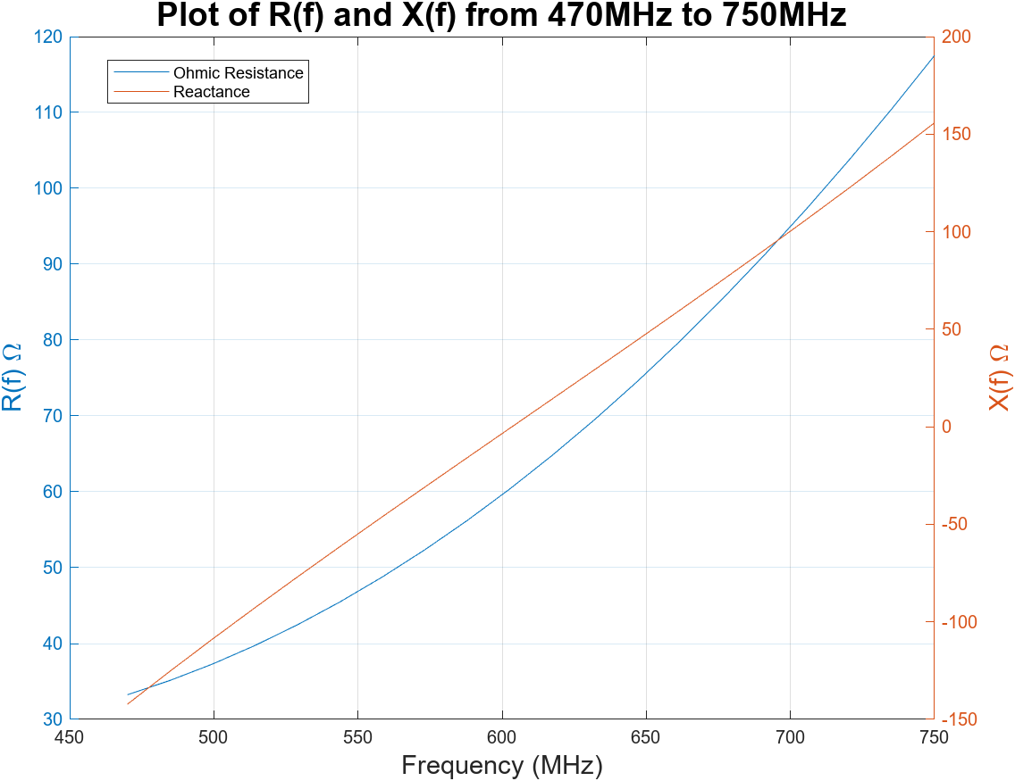

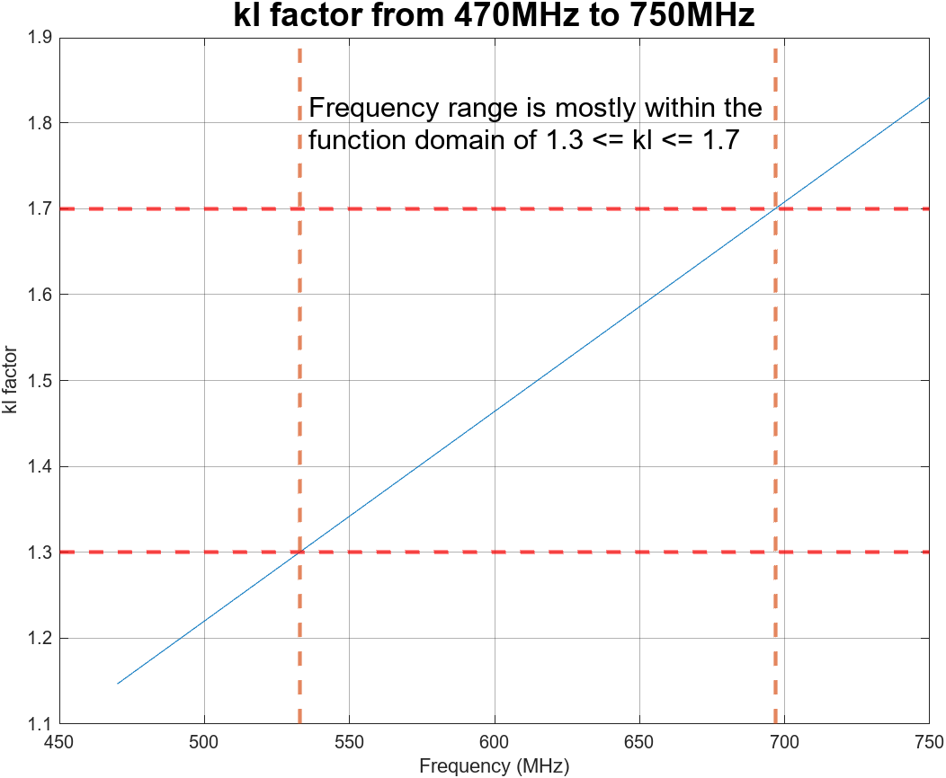

* 1. This antenna is now placed in a corner reflector of 90o angles at a distance s =0.5λ from the apex of the corner at 600 MHz.
     1. Calculate the new Zin of the antenna.

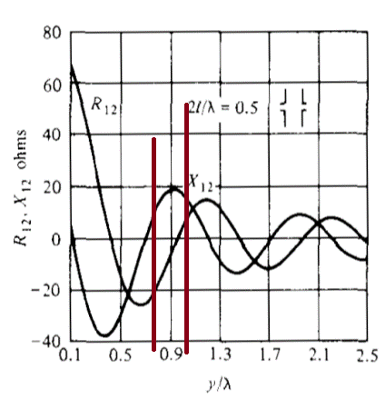

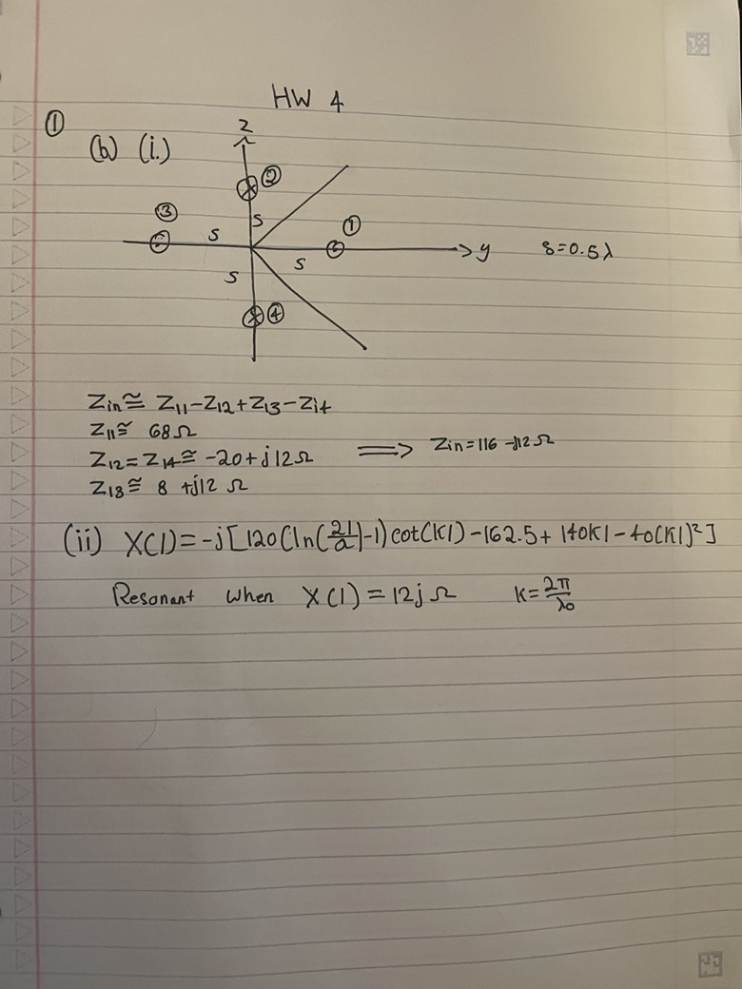

* + 1. Change the antenna length so as to cancel the reactance of the images. What is the new resonant length and resistance. (Normally, you should be two iterations, but let us just do one)

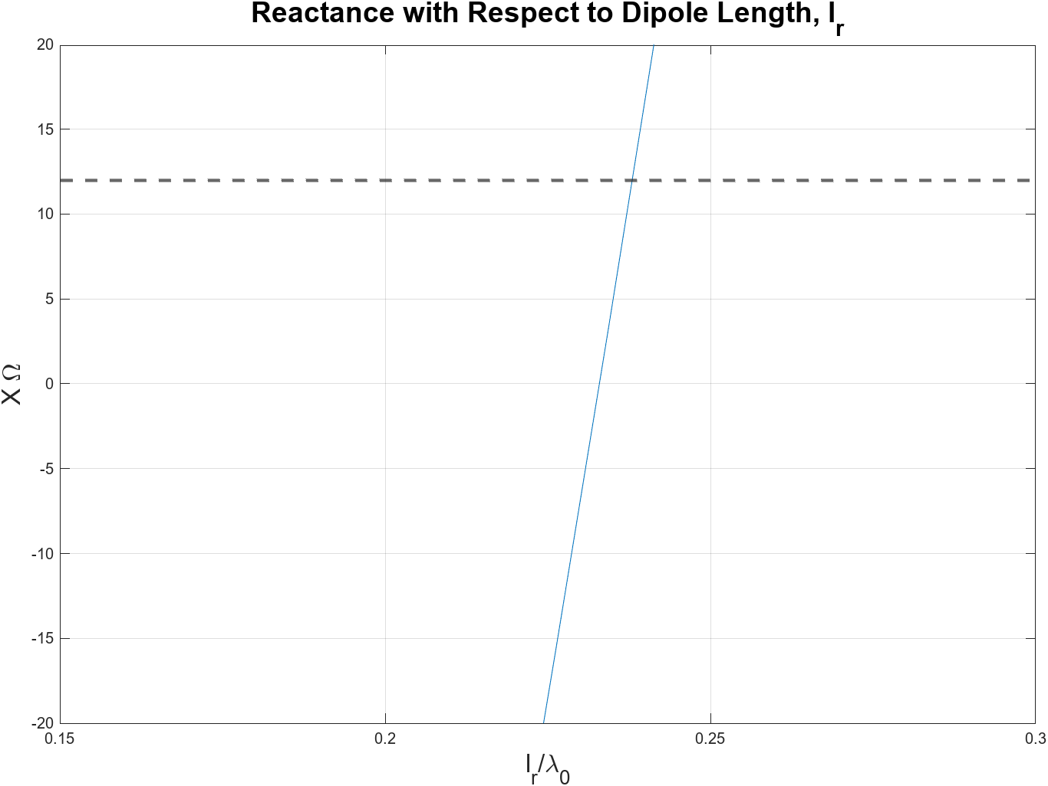

$$l_{r}≈0.238λ_{0}=11.89 cm$$

$2l_{r}=23.78 cm$ (New resonant length)

Figure 3 Code

%% Find new resonant length

clear all

close all

clc

syms l

lambda = 299792458/600e6;

k = (2*pi)/lambda;

alpha = 0.006*lambda;

X(l) = -1*( 120*(log(2*l/alpha) - 1) * cot(k * l) - 162.5 + 140*k*l - 40*(k*l)^2 );

l1 = linspace(0, 0.8, 100) .* lambda;

y1 = X(l1);

plot(l1/lambda, y1);

yline(12, '--', 'LineWidth', 2);

ylim([-20, 20]);

xlim([0.15, 0.3]);

title("Reactance with Respect to Dipole Length, l_{r}", 'FontSize', 18);

xlabel('l_{r}/\lambda_{0}', 'FontSize', 16);

ylabel('X \Omega', 'FontSize', 16);

grid on;

* + 1. Calculate the Zin of this antenna at ±10% bandwidth (540, 660 MHz) and the resulting VSWR.

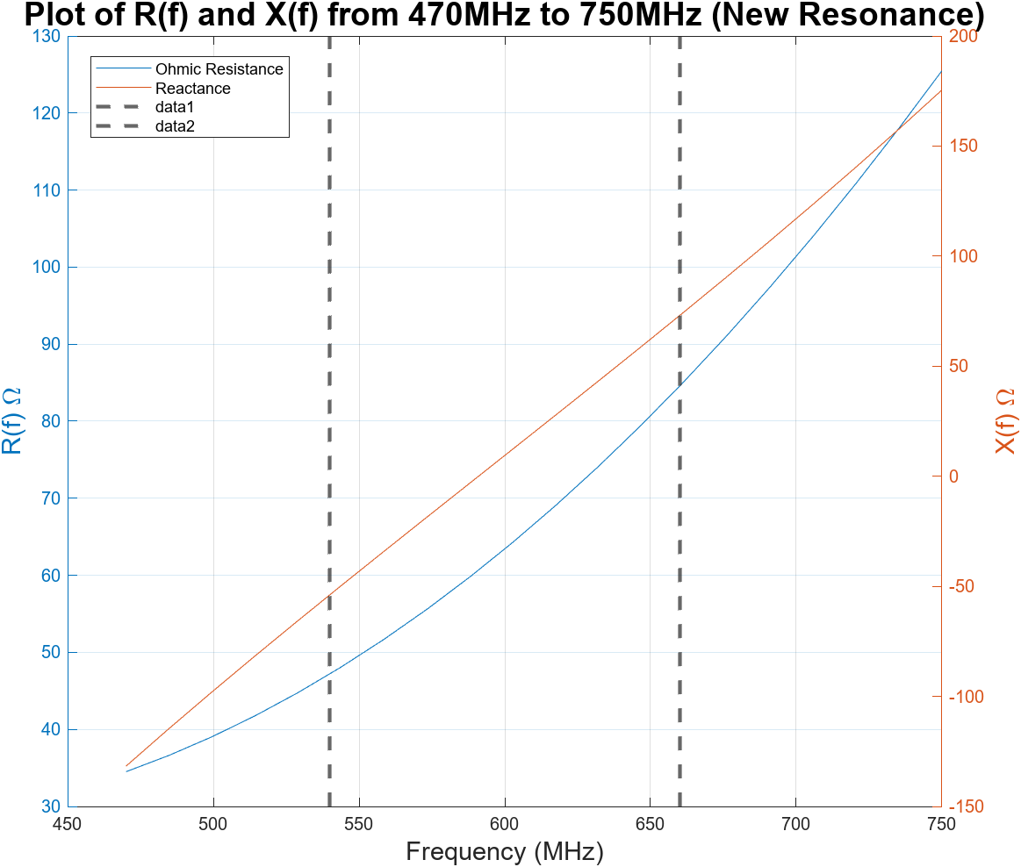

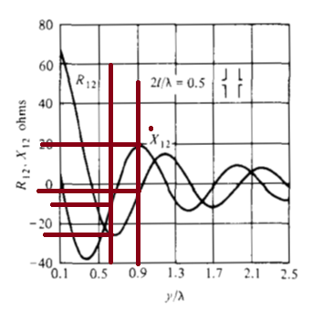

540 MHz Mutual Coupling

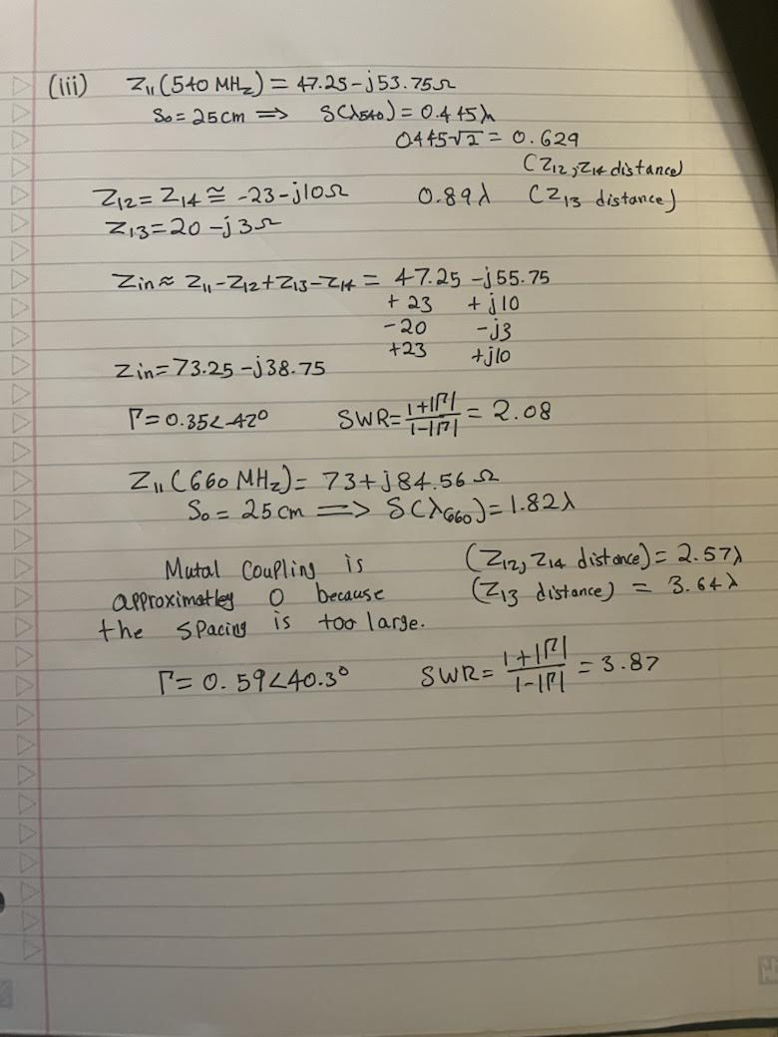

1. Answer the following questions in short clear sentences. Not more than half a page for each questions.
   1. Which antenna will have more gain (all antennas have the same total length (L > 4λ): A traveling-wave antenna? A Yagi-Uda antenna? A log-periodic dipole array?

The yagi antenna has the most gain because the log-periodic and traveling wave antenna improve bandwidth whereas yagi has relatively narrower bandwidth but much higher gain. Also, when the yagi antenna length is increased to L>4 $λ$, it directivity increases, whereas, for both log-periodic and traveling wave will only get a higher BW.

* 1. Assume you have an antenna sending a circularly-polarized wave and a short dipole receiver with a power detector (diode). How would you know if the polarization is left handed or right handed?

A dipole will always receive 50% of circular wave power if it is in constant orientation. To detect polarization, we must rotate the dipole and plot the received power. If the dipole is rotated in counter clockwise direction and the wave is RHCP then the received power would have peaks on the same axis, however, if the power peaks on both sides of the y-axis then it is the opposite polarization.

* 1. Design a log periodic dipole antenna for 50 MHz to 800 MHz operation. Label all relevant dimensions. Estimate the directivity.

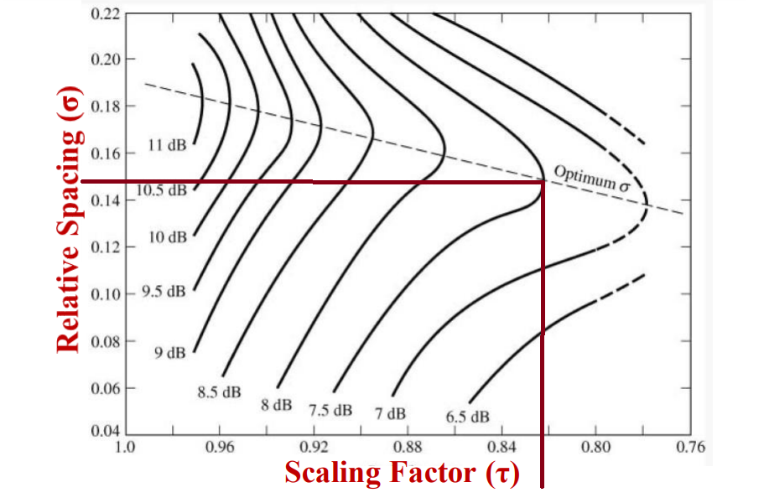

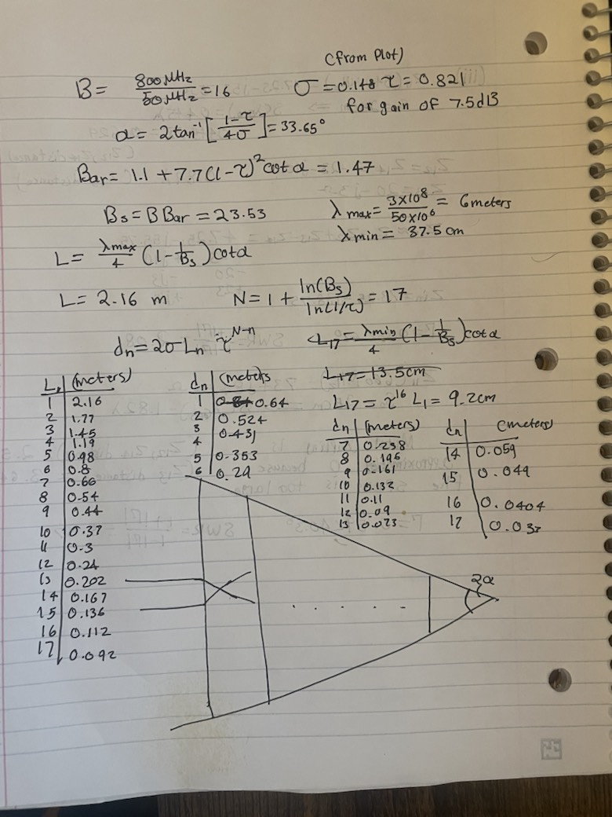

* 1. What limits the bandwidth of a planar spiral or log-periodic antenna (low frequency and high frequency limits)

|  |  |  |
| --- | --- | --- |
|  | Low Frequency Limit | High Frequency Limit |
| Spiral | The outer radius. | The length of inner radius and the waveguide will also start to have multiple TE and TM modes at higher frequency. |
| Log Periodic | The length of the longest dipole. | The length of the shortest dipole. |

* 1. What happens to the directivity, beamwidth and sidelobes of an array pattern if reverse tapering is done on the array? Assume the array is >>5λ.

$↑SLL$, $↓$ beamwidth, and $↑$ directivity.



1. Consider a 13-element array on the z-axis with elements at -6d, -5d, …, 0, … , +5d, +6d. The spacing between the elements, d, is 0.62λ.
   1. Use a raised cosine square taper distribution and get a pattern with a sidelobe of -27±1 dB. Plot the pattern with no phase distribution and determine its HPBW, FNBW and directivity.

$A\left(z^{'}\right)=E+\left(1-E\right)\cos^{2}\left(\frac{π}{l}z^{'}\right)$ optimal E $≈$ 0.268

HPBW = 94.1 - 85.9 = 8.2 degrees

FNBW = 102.7 - 76.9 = 25.8 degrees

D0 (linear) = 13.3775

SLL (dBi) = -27.0454

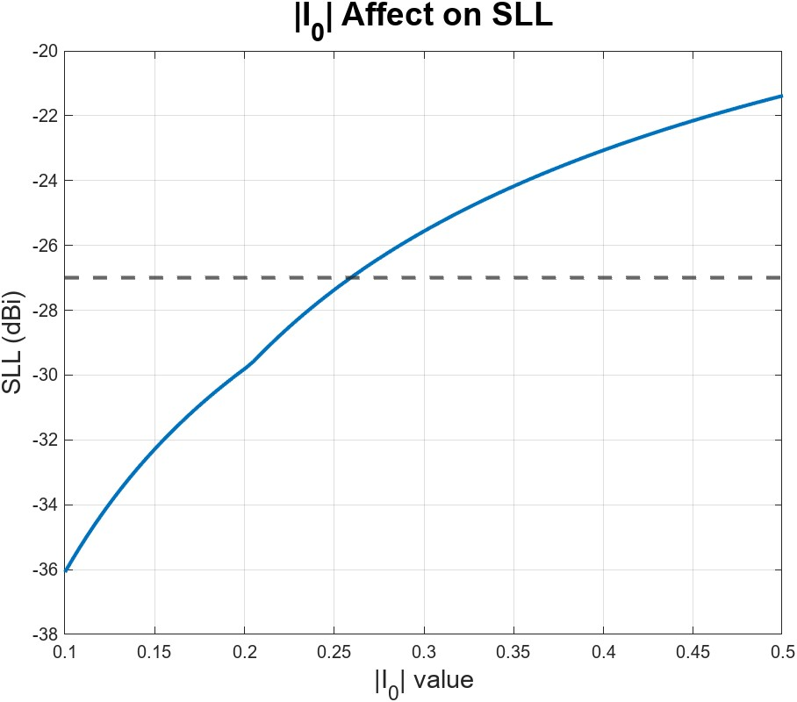

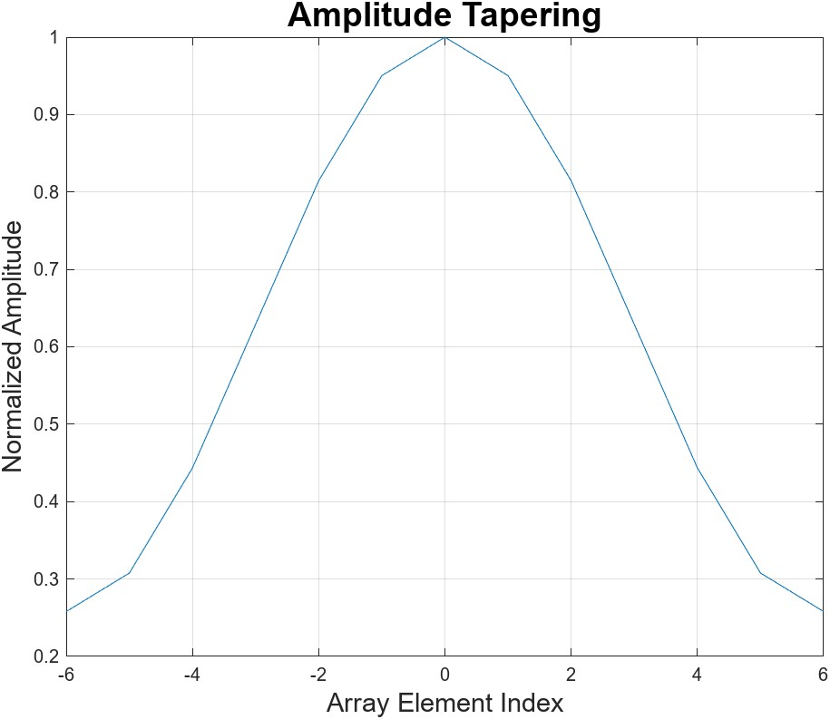

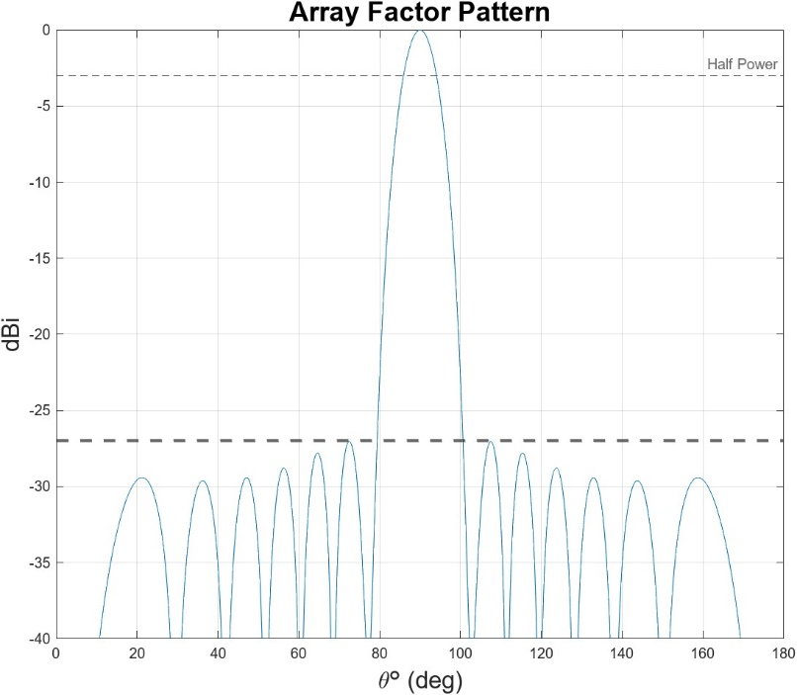

* 1. Now calculate the phase distribution over the array so that it scans to θ=55o. Plot the pattern and determine its HPBW, FNBW and directivity. Are the sidelobe levels the same as the case in (a)?

The sidelobe levels remain about the same, however, when we scan to 55 degrees, we get a grating lobe.

HPBW = 59.83 - 49.86 = 9.97 degree

FNBW = 69.38 - 37.37 = 32.01 degree

D0 (linear) = 10.7009

SLL (dBi) = -27.0448

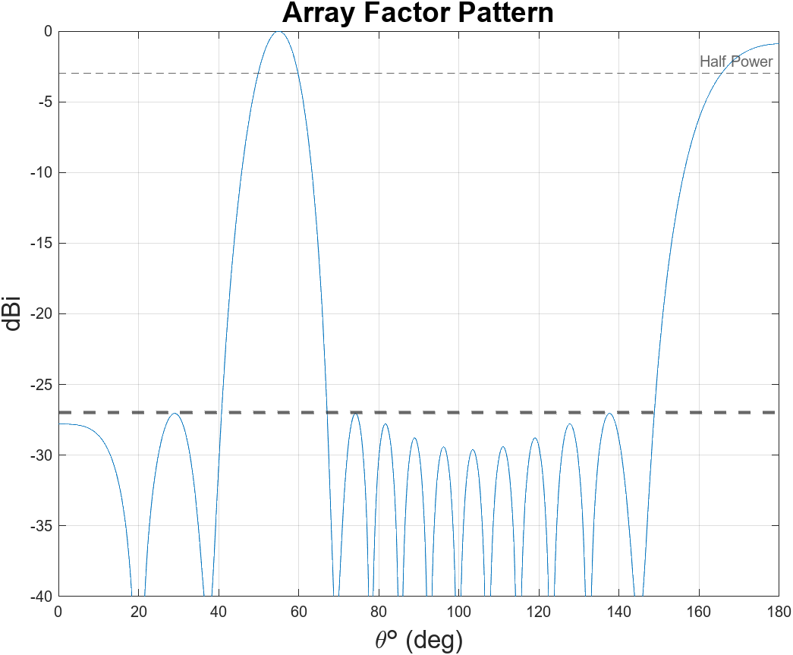

* 1. Assume that you have a 3-bit phase shifter with l linear gain difference of -2dB between the 0 degree bit and 315 degree bit (the 315 degree bit has 2 dB more loss than the 0 degree bit and this loss is linear with phase bit). For a scan angle θ=55o, calculate:
     1. The far-field pattern error due to the digitized phase shifter.

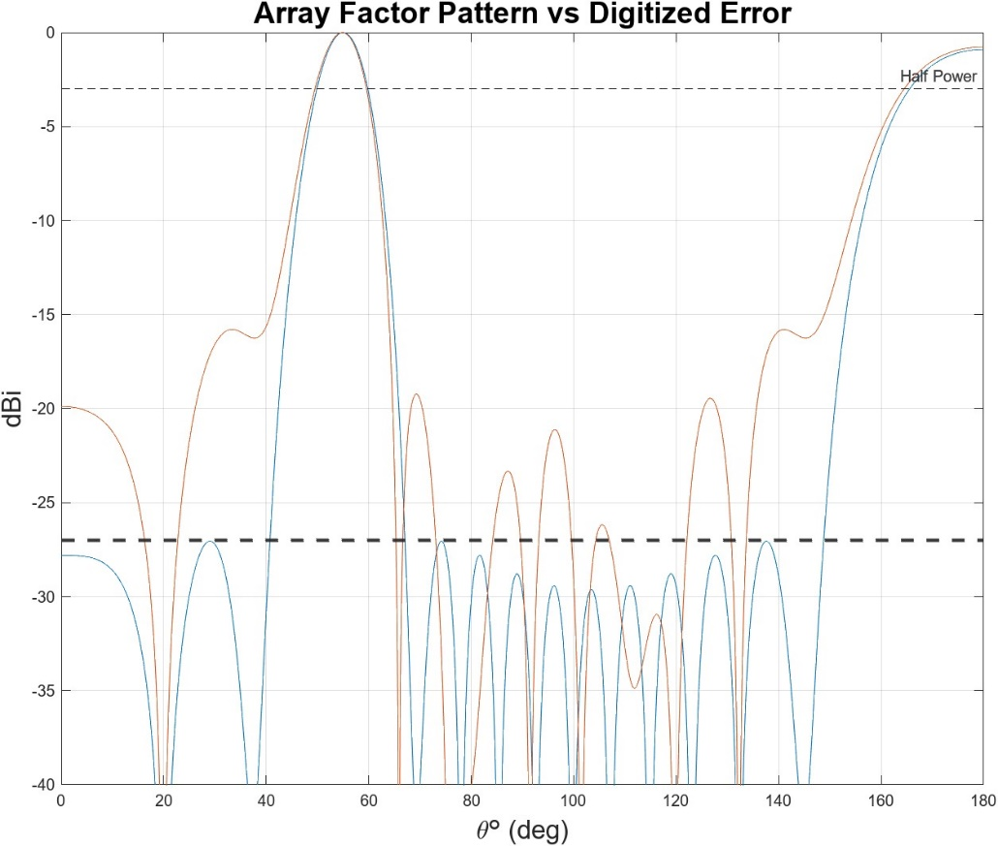

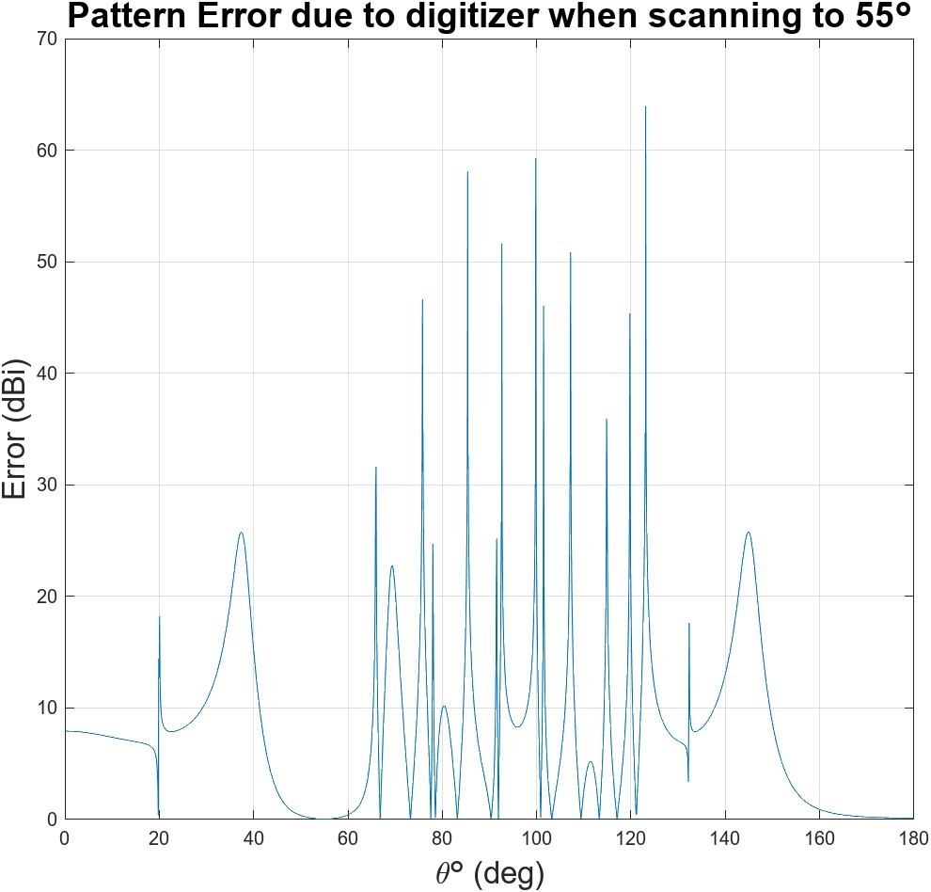

* + 1. The far-field pattern error due to the amplitude variation.

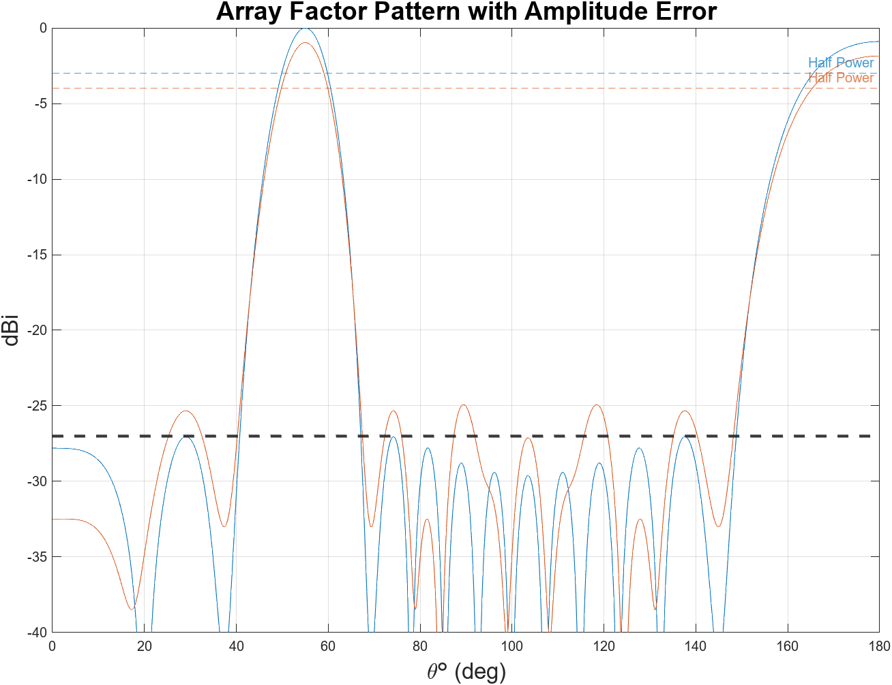

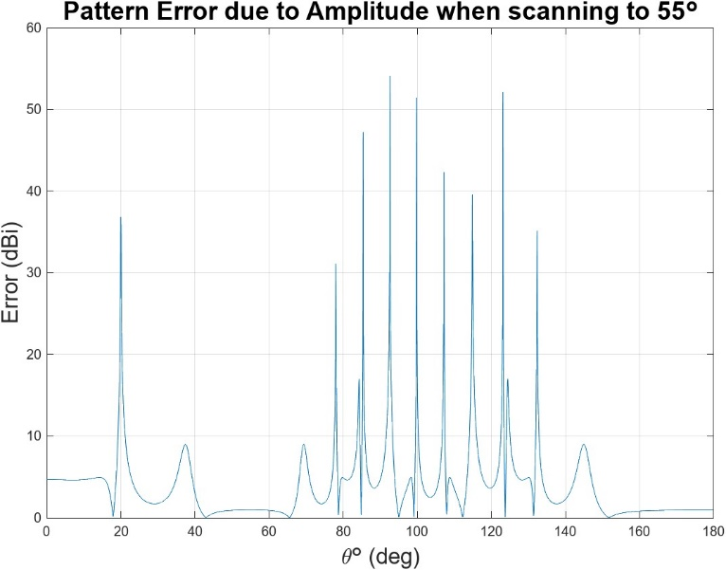

* + 1. Add (a) and (b) to the ideal pattern obtained in (b) and get the final pattern in dB. determine its HPBW, FNBW, SLL and directivity. If you have a choice of getting a 4-bit phase shifter or a 3-bit phase shifter with less amplitude variation, which one will you choose to satisfy your SLLs?

I would choose the 4-bit phase shifter because it has a much greater impact on my SLLs than amplitude. Also, we also could change the amplitudes for each array element to offset the phase shifter loss.

HPBW = 59.62 - 49.44 = 10.18 degrees

FNBW = 66.214 - 18.730 = 47.4840 degrees

D0 (linear) = 9.5680

SLL (dBi) = -16.2326

